

**Disclaimer: The content is curated from online/offline resources and used for educational purpose only**

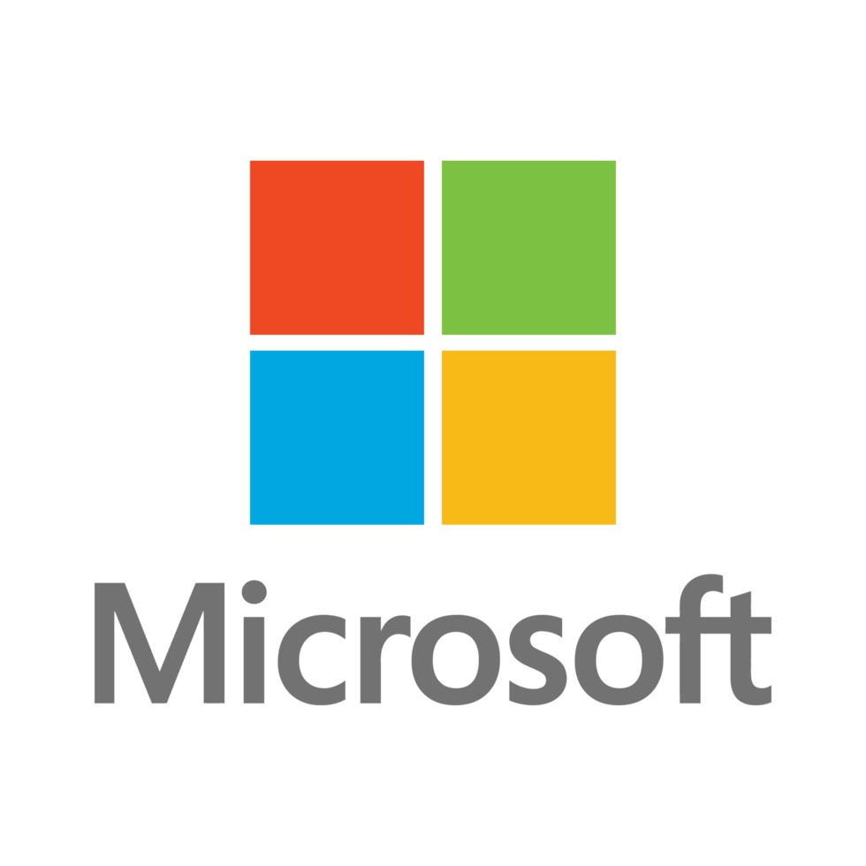

**LAB MANUAL**

**Installing Python and setting up the environment**

**Installing Python and setting up the environment**

**Objective:**

To execute Python code, you need to have a Python interpreter installed on your system.

* Install a supported version of Python compatible with Local Machine .
* Install an editor.
* Install the Cloud Client Libraries for Python
* Check which version of Python, if any, is installed on your machine
* Use Python on the Web with online interpreters

**Equipment Required:**

1. Install VS Code - https://code.visualstudio.com/download
2. Download Python Installer File - https://www.python.org/downloads/

**Prerequisites:**

1. Basic Computer Skills - Anyone starting to learn computer programming needs basic computer skills. Python is a cross-platform language, so it makes no difference whether you use a macOS, Windows, or even Linux.

**Problem Statement:**

To successfully install Python and set up the necessary environment to perform python simple program and, ensuring that all required libraries and tools are available and functioning correctly.

**Procedure:**

Setting up the Environment:

1. Download Python Installer File
2. Run the Installer
3. Install Python
4. Verify your installation
5. Install VS Code Editor
6. Run your python first program

**1. Download Python Installer File:**

Go to the official Python website ([**https://www.python.org/downloads/**](https://www.python.org/downloads/)**)** and download the latest version:

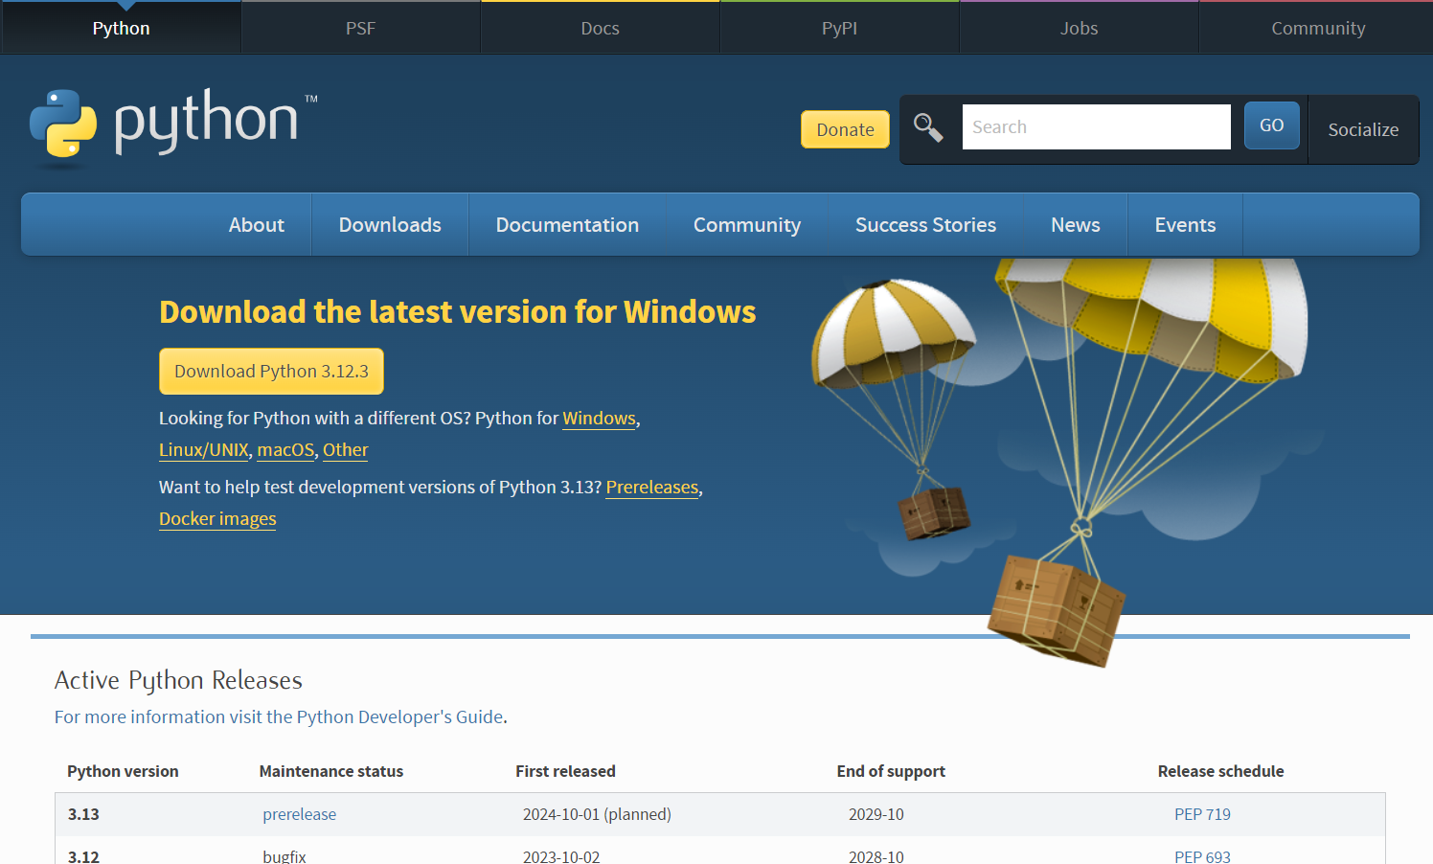

The Python.org website automatically detects your operating system and gives you the right installer.

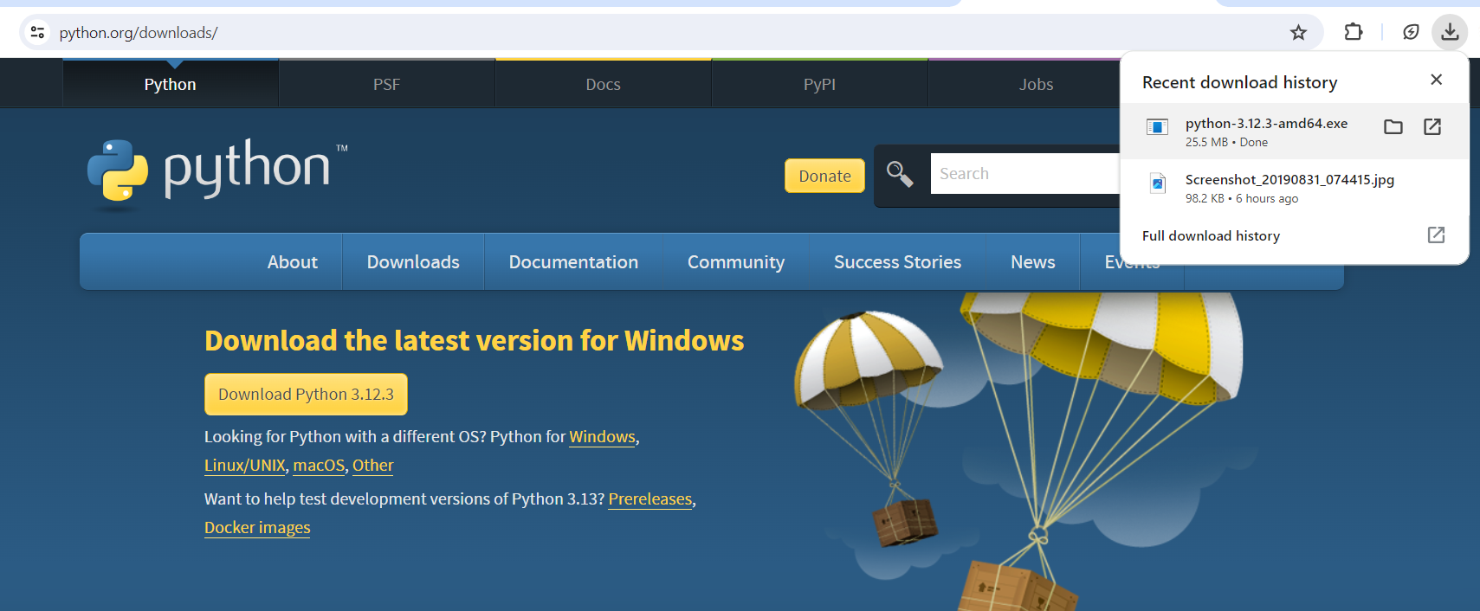

Downloaded.

**2. Run the Installer**

Now, go to your download folder and run the installer you just downloaded.

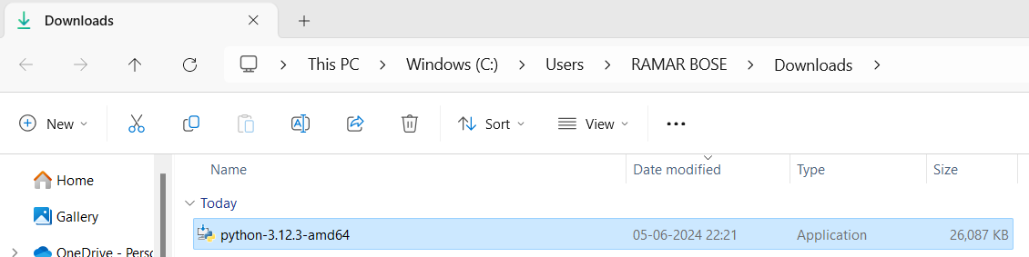

Click that file to install.

**3. Install Python**

Once you have run the installer,

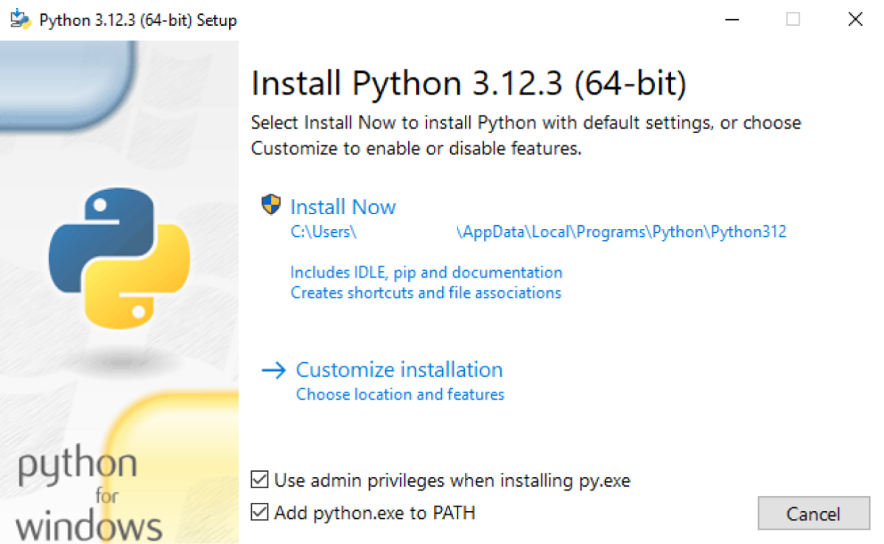

On the screen, you will see two options: Install Now and Customize Installation. We suggest you skip all customization steps and simply click Install Now.

* Check on Add python.exe to PATH as it ensures Python is added to our system's PATH variable.(Recommended)
* Click Install Now, as it will include all the necessary files needed later.

Note: This makes it easier to run a Python Program from the command prompt (cmd) directly without specifying the full path of the Python executable.

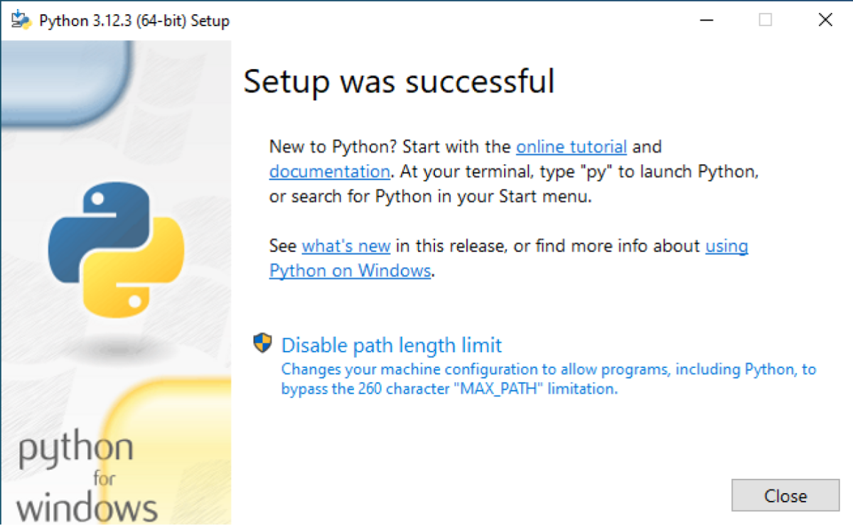

After using this option, Python will be successfully installed in your device.

**4. Verify your installation**

After the installation is complete, you can verify whether Python is installed by using the following command in the command prompt.

**python --version**

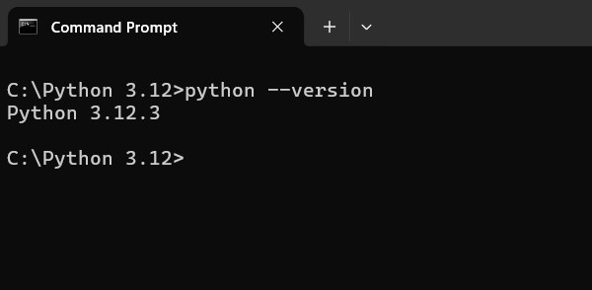

Now, you are all set to run Python programs on your device.

**5. Install VS Code Editor**

Go to the VS Code Official website and download the Windows installer. Once the download is complete, run the installer and follow the installation process.

1. Download

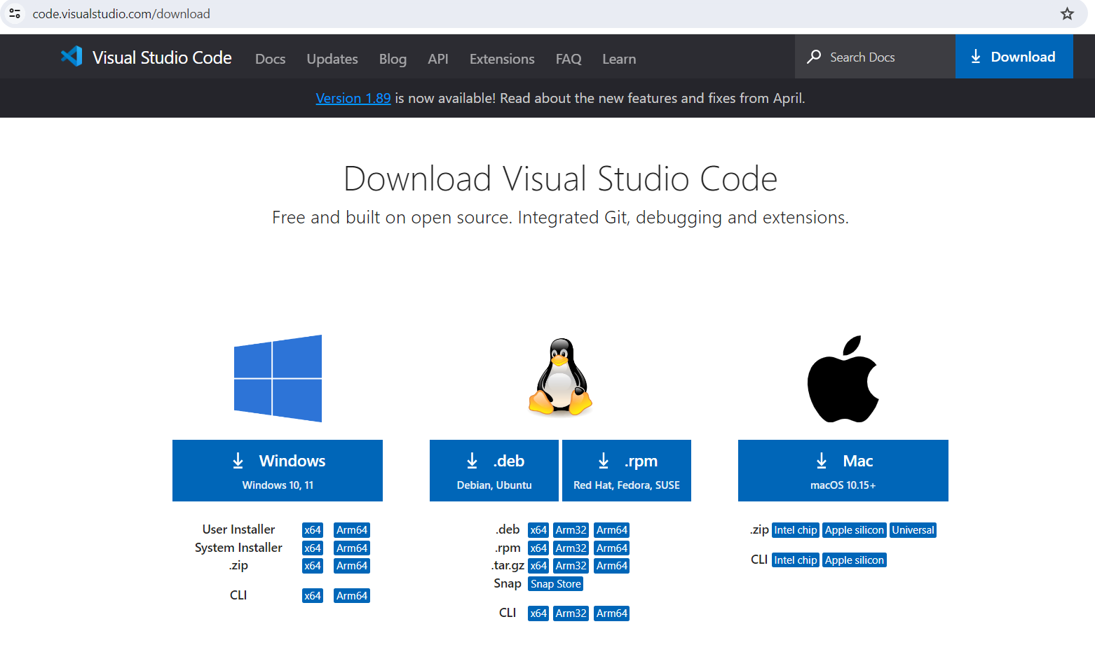

1. Install

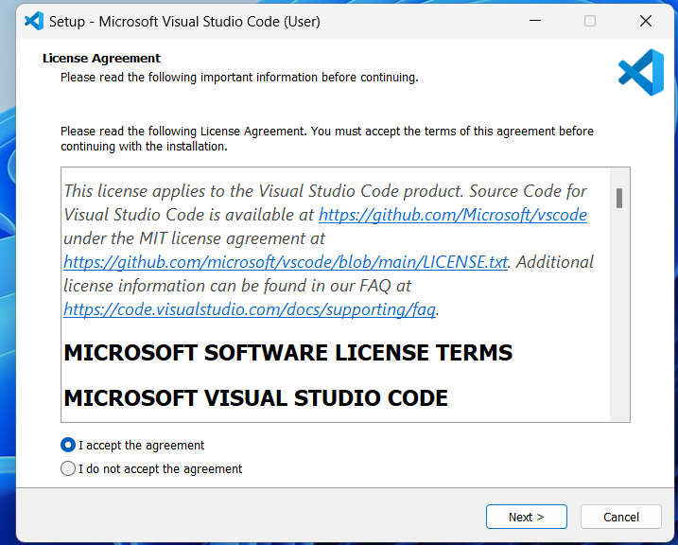

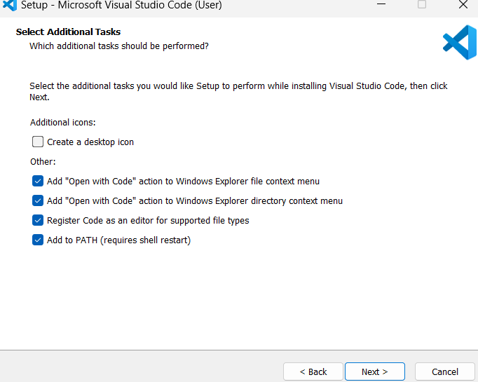

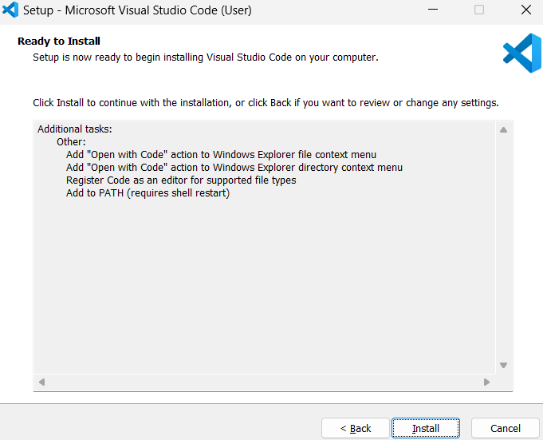

Click Finish to complete the installation process

**6. Run your python first program**

First open VS Code, click on the File in the top menu and then select New File.

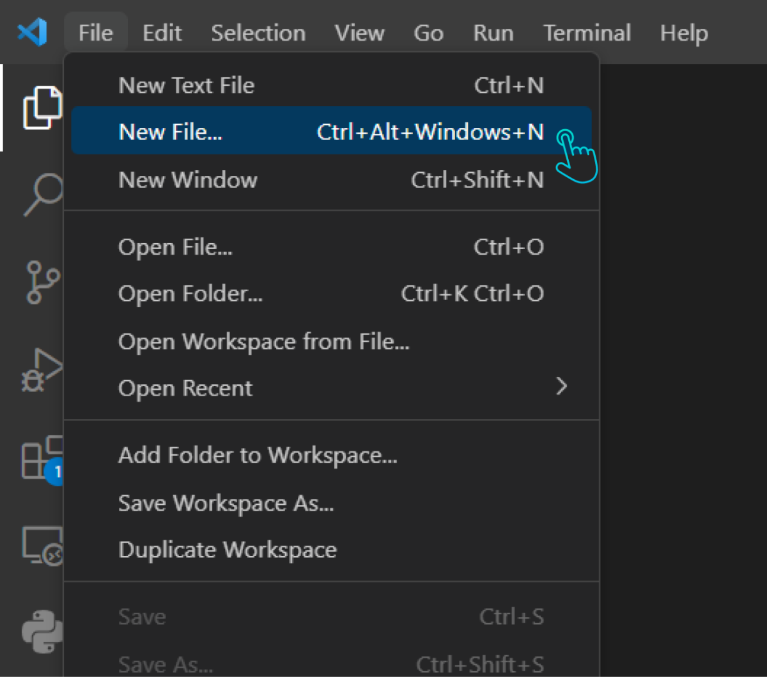

Then, save this file with a .py extension by clicking on File again, then Save As, and type your filename ending in .py. (Here, we are saving it as Hello_World.py)

Note: Before you start coding, make sure the Python extension is installed in VS Code. Open VS Code and click on Extensions on the left sidebar. Then, search for the Python extension by Microsoft and click on install.

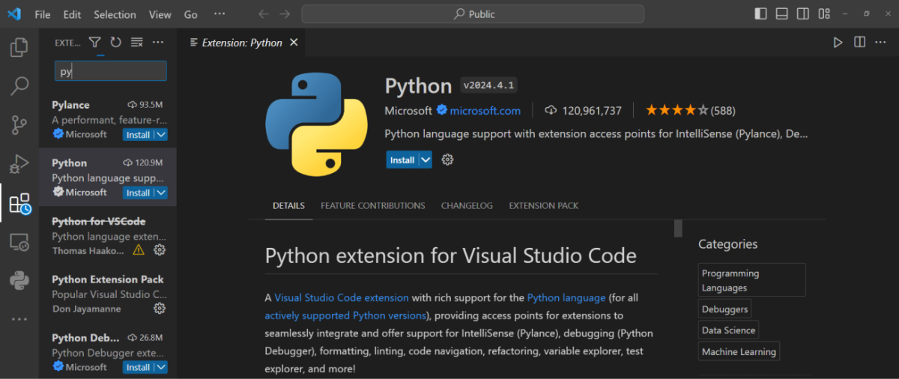

Now, write the following code into your file:

print("Hello World")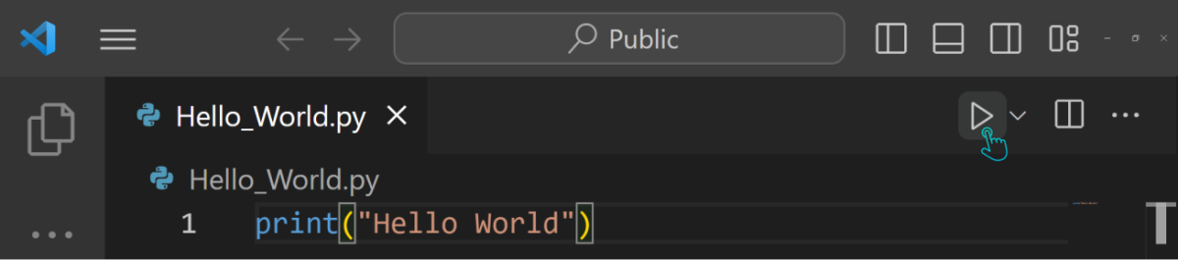

Then click on the run button on the top right side of your screen.

**Output:**

You should see Hello World printed to the command prompt.

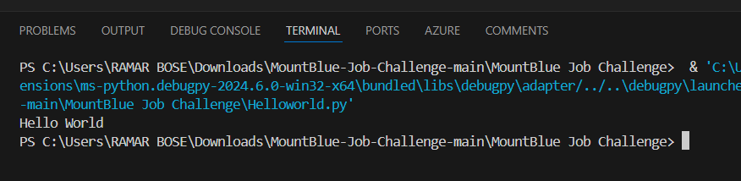

**Disclaimer: The content is curated from online/offline resources and used for educational purpose only**